1.

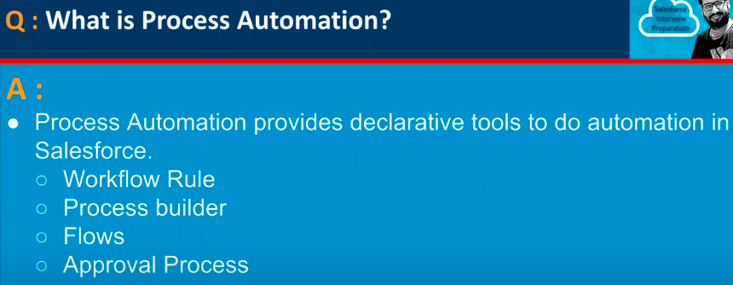

2.

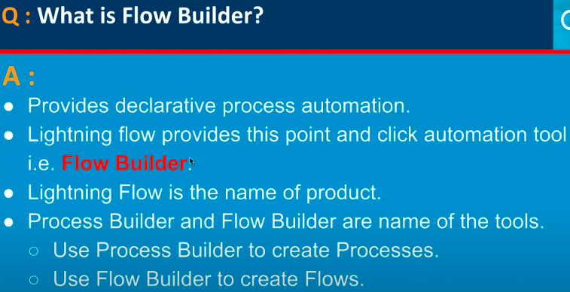

3.

4.

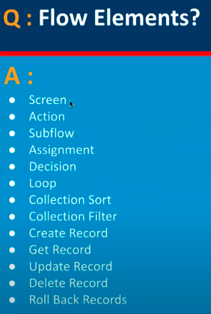

5.

6.

7.

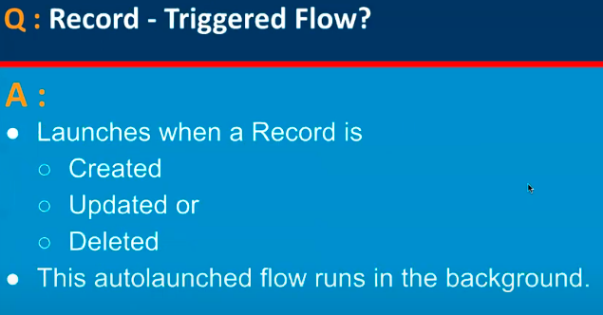

8.

9.

10.

11.

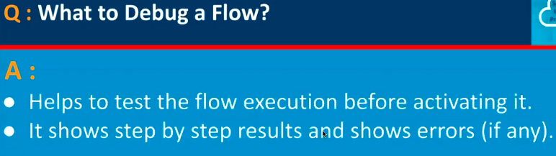

12.

13.

14.

15.

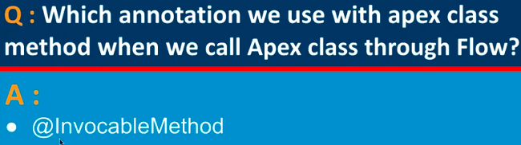

16.

17.

18.

19.

20.

21.

22.

23.

24.

25.

26.

27.

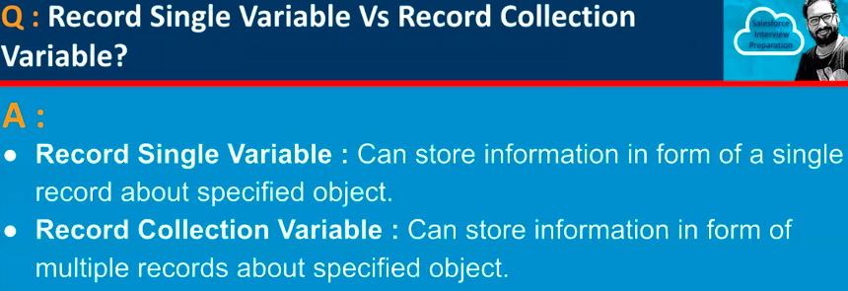

28.

29.

30.

